Music Project Write-up – Ethan Hitchcock – 1408202

My project is an adaption of the initial code provided by Dr. Roysam. After playing with the code by inputting the value of the note which corresponded with a specific frequency, I attempted to modify the wave table and the envelope effect to simulate a piano key press. However, this proved very difficult to create a realistic piano key tone. Instead, I modified the program into two sections.

The first section no longer askes for the user to input the value of the note to play. It calls from an array in the initialisation of the code containing notes and pauses between notes to generate a simple scale. This proves that it would be possible to write the notes into an array to generate a song. However, it would become more complicated with different timings for notes and the addition of chords.

The second section of the project generates chords by superposing the individual notes into a single vector. Each chord is assigned a numerical value and the user is prompted to input a value to call for a certain chord. 1 corresponds to C major, 2 corresponds to C minor, 3 corresponds to D major, and so on as shown in the image below.

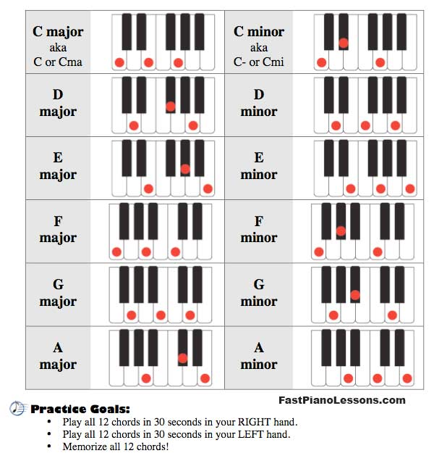

A chord for a piano is when 3 different keys are pressed simultaneously. This was simulated by creating each note individually and, before the MATLAB function to output sound was called, summing the 3 notes together. This approach allowed for the simulation of a chord. The second section of the project runs indefinitely or until 0 is input by the user.